**LICENSING APPLICATION WITH ESRI INTEGRATION**

**USER GUIDE**

Contents

**1.** **Introduction** 1

**2.** **Pre-requisites** 2

**3.** **User Roles** 2

**2.1 Administrator** 2

**2.2 Applicant** 2

**2.3 Reviewer** 2

4. User Guide 3

4.1 Administrator 3

**3.1.1 Installation Process** 3

**3.1.2 Post-Deployment Activities** 3

3.1.3 Basic Provisions 14

4.2 Applicant 15

3.2.1 Creating new Application 15

3.2.2 Viewing Existing Applications 18

3.2.3 Viewing License 20

4.3 Reviewer 21

4.3.1 Reviewing a Polygon 22

4.3.2 Altering a Polygon 23

4.3.3 Approving / Rejecting Polygon 23

5. Troubleshooting 24

# **Introduction**

This user guide provides instructions for using a web-based SFDC application designed to enhance the License Creation process. The goal of this application is to improve the accuracy and efficiency of the license request process by integrating ESRI Maps with Salesforce (SFDC).

Using this application, applicants can easily submit their requests and plot the relevant area on the map using ESRI Libraries. Reviewers can review and make changes to the map before approving or rejecting the request.

This application is designed for Administrators, Applicants, and Reviewers, with each user having specific permissions and responsibilities within the application. By leveraging ESRI Libraries and SFDC, this application provides a streamlined and user-friendly experience for all parties involved in the permit/license request process.

# **Pre-requisites**

* Org must be having OmniStudio installed with version greater than or equal to
* Communities must be enabled
* **Customer Community Plus** licenses are required for the community Users
* License of Public Sector Solutions are required for the functionality related to Business License applications.
* Chatter has to be enabled for the template to be available while creation of community. For enabling Setup > Quick Find > Chatter settings > Enable Chatter Settings. Click on Save
* Lightning Web Security should be enabled. For steps refer to section Troubleshooting.

# **User Roles**

There are mainly three user roles in this system: Administrator, Applicant, and Reviewer. This section provides an overview of each user role's responsibilities and tasks in the permit/license request process. The Administrator is responsible for setting up and configuring the application, while the Applicant submits permit/license requests and the Reviewer reviews and approves/rejects the requests.

## **2.1 Administrator**

The Administrator is responsible for setting up and configuring the application for use. This involves establishing the community, making necessary configuration changes, and ensuring that the necessary resources are in place for the application to run. The Administrator also manages the user accounts, including setting up new users and assigning roles.

## **2.2 Applicant**

The Applicant is responsible for submitting a permit or license request using the application. They can self-register in the community and raise an application by providing the necessary details, view their application status, and verify their licenses. The core action item of an applicant is to raise an application and view its status.

## **2.3 Reviewer**

The Reviewer is responsible for reviewing the license request raised by the Applicant. They can review the request and make changes to the location before approving or rejecting it. Once an entry is approved or rejected, it cannot be modified by the Reviewer. Only the Administrator will be able to modify it if necessary.

# User Guide

The section provides step-by-step instructions for different user roles within the application. Each section contains specific guidance for the user's role and covers the necessary actions that they need to take in order to use the application effectively. The guide aims to provide clear and concise instructions that will help users to navigate the system with ease.

## Administrator

The Admin has access to advanced features and settings that allow them to manage and configure the application to meet their organization's needs. This section provides an overview of the post-deployment activities that an Admin needs to perform to set up the application and outlines the basic provisions that are available to them.

### **3.1.1 Installation Process**

Click on the below links and enter your org credentials for the installation to be initiated.

Managed Package

Use this URL to install the package into any organization:  
<https://login.salesforce.com/packaging/installPackage.apexp?p0=04tHr000001dqIl>  
  
Note: If you are installing into a sandbox organization you must replace the initial portion of the URL with <http://test.salesforce.com>

Unmanaged Package

Use this URL to install the package into any organization:  
<https://login.salesforce.com/packaging/installPackage.apexp?p0=04tDp000000VCdB>  
  
Note: If you are installing into a sandbox organization you must replace the initial portion of the URL with <http://test.salesforce.com>

### **3.1.2 Post-Deployment Activities**

1. The custom permission "Delegated_User" should be added to the admin user to enable them to modify the BLA regardless of its status.
2. Execute steps as per the below link  
   <https://help.salesforce.com/s/articleView?language=de&id=sf.os_create_an_omnistudio_permission_set_for_standard_experience_users_7203.htm&type=5>
3. Goto quick find > Sharing settings > Edit

* Change the value for “Default Internal Access” and “Default External Access” to “Public Read/Write” for the below objects
  + Omni DataPack
  + Omni Data Transformation
  + Omni Electronic Signature Template
  + Omni Process
  + Omni Process Transient Data
  + OmniScript Saved Session
  + Omni UI Card

Setup > Profiles > Open profile of administrator > Custom Permissions > Edit > Add Custom Permission “Delegated User” and click on “Save”

1. Assign the "Reviewer" permission set to the users who will be performing the role of a reviewer.

Open the User detail page of the User and goto section “Permission Set Assignments”, Click on “Edit Assignments” and move “Reviewer” to enabled section and click on “Save”

1. Create a new profile for the Applicants by using the license “**Customer Community Plus**” and this will be used in the community.
2. Create a queue named "Reviewers", enable it for object “BusinessLicenseApplication” and add all the users who will be reviewers to the queue. This will ensure that they are notified whenever a new Business License Application is created.
3. Goto quick find > permissions sets > Esri Community > System Permission -> Grant community users access to LPI features. -> Make it as TRUE and save.
4. Goto quick find > permissions sets > Esri Community > Object Settings > “**Omni Data Transformation Items**” and “**Omni Data Transformations**”.
5. To enable the map rendering in the application, the ESRI account's API key must be obtained and updated in the "ApiKey" record of the Utils metadata.

Setup > QuickFind > Custom metadata > Utils > Manage Records> ApiKey

1. **Importing Omniscript**
   1. Click on App launcher and select “Omnistudio”. Click on “Omniscripts” Tab
   2. Click on Import button and upload the below file or download the file from the [Git Hub site](https://github.com/SalesforceLabs/esri-maps).

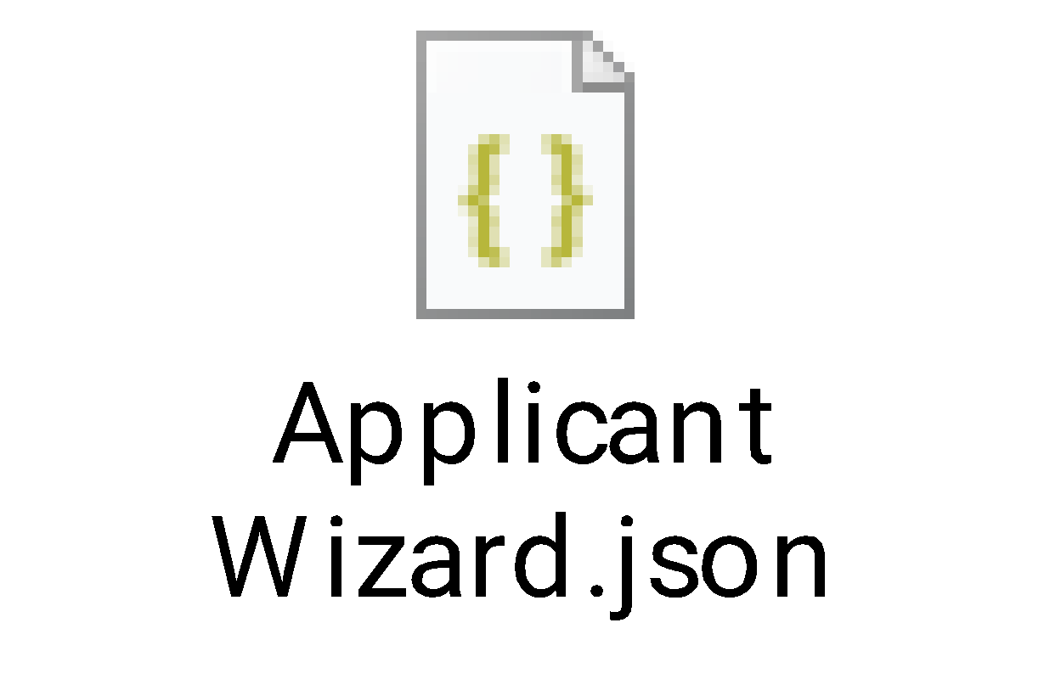

* 1. Ensure to check all the checkboxes before proceeding.
  2. Click on Activate now at the end.
  3. Open the Omniscript, click on “New Version” and then click on “Activate”. There could be few intermittent issues that might occur if we just import and activate and so creating a new version and activating so that all necessary components will be in place.

1. **Creating Community**
   1. Click on Setup > Go to quick find > All sites > Click on “New”

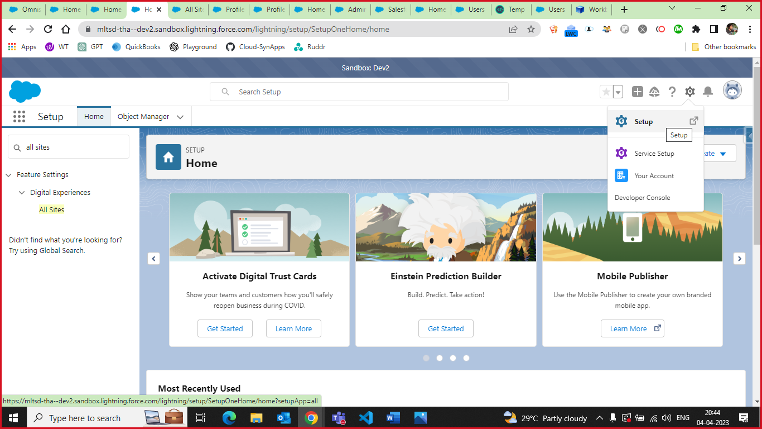

* 1. Choose “Applicant Community” in the templates and proceed further
  2. Assign the name "Esri_Gis" or any other desired name, but make sure to update the "SiteName" entry in the "Utils" Metadata to reflect the new site name.

Quick find > custom metadata > Click Manage Records beside Utils and click on Edit for the record SiteName.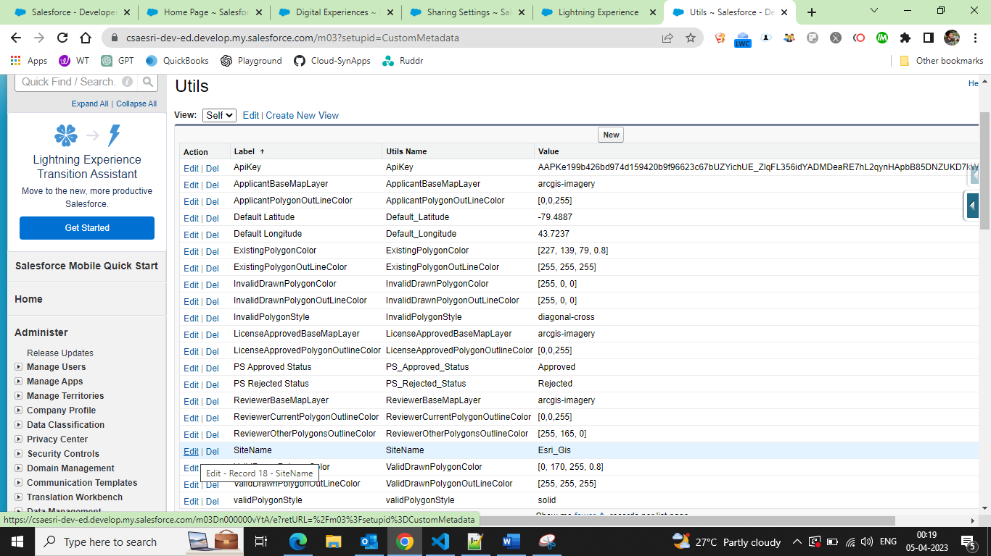

* Note: When referencing Visualforce pages contained in the component, this version of the accelerator assumes that the Experience Cloud URL does not have a suffix. When creating your Experience Cloud site possible do not add a suffix to the URL if possible.
  + If this Org already has an Experience Cloud site that does not contain a suffix, then enter the name of that Experience Cloud site into the Utils > SiteName custom metadata field. Doing this will ensure that the VisualForce pages are referenced correctly.
    - Note also that any community profiles that require access to the ESRI site will need to be granted access to the Experience Cloud site that does not contain a Suffix. Failure to add these profiles will result in a login page instead of the ESRI map.
  1. After site creation is successful. Click on “Administration”. Click on Pages. Select Fore.com under Advanced Customizations.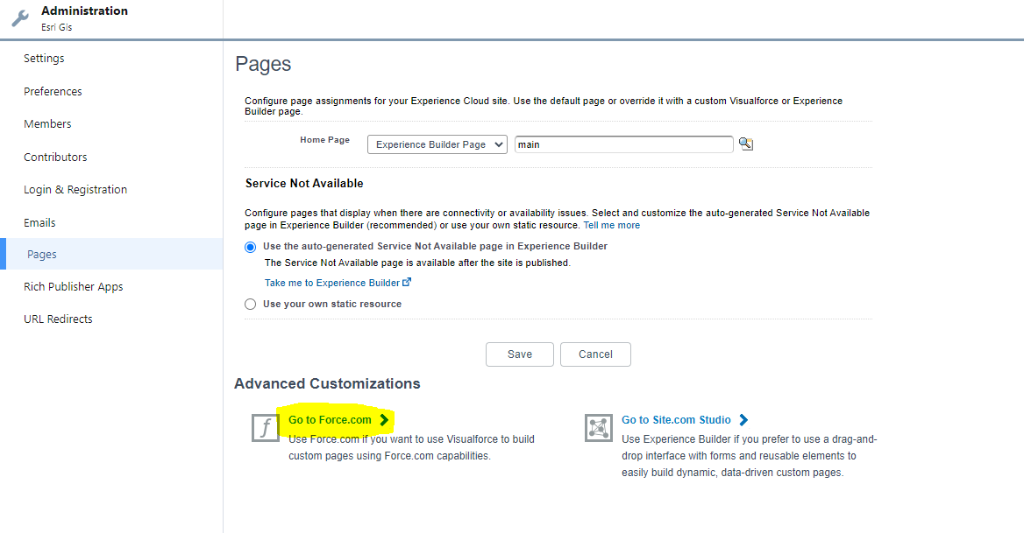
     1. Click on Edit for the section Site VisualForce pages and add the below
        1. Applicant_Create_Page
        2. Applicant_License_Approved_Page
        3. Applicant_Page
     2. Click on Save and it should appear like below.

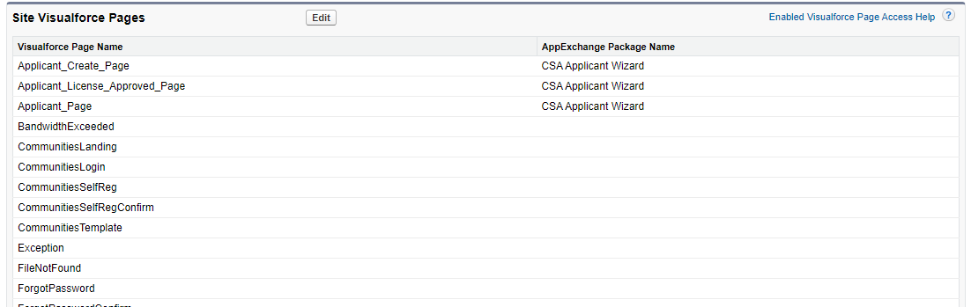

* 1. Under “Administration” goto section “Members” and add the profile created for the Applicant above and scroll down to the section Site Role choose “Custom” and mention as “Applicant” for role “Customer”

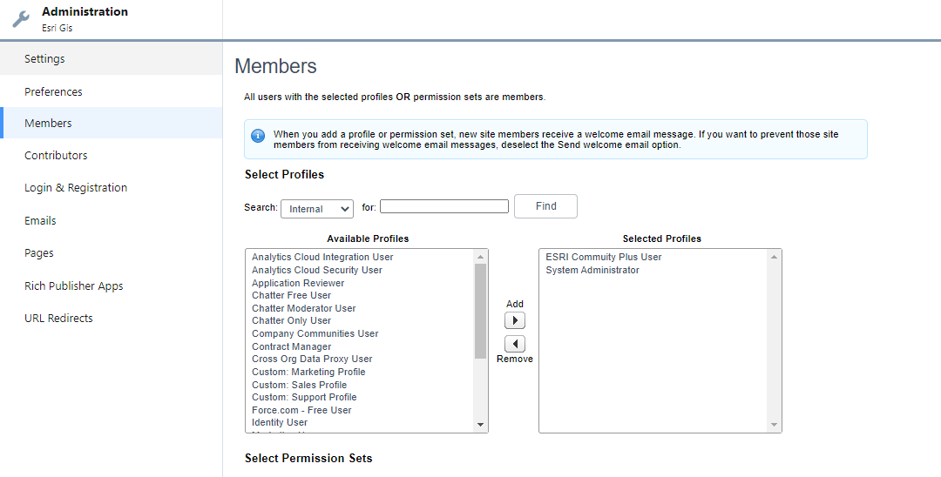

* 1. Under “Administration” goto section “Login & Registration” and check the checkbox “ Allow customers and partners to self-register” present under “Registration Page Configuration” and choose the below options
     1. Registration Page Type : Configurable Self-Page
     2. User Fields : Last Name, FirstName, User, Email
     3. Configurable Self-Reg Handler: CreateEsriCustomerUserHandler
     4. Execute Registration As : Choose any admin
     5. Choose a profile that was created above for the applicants and click on “Save”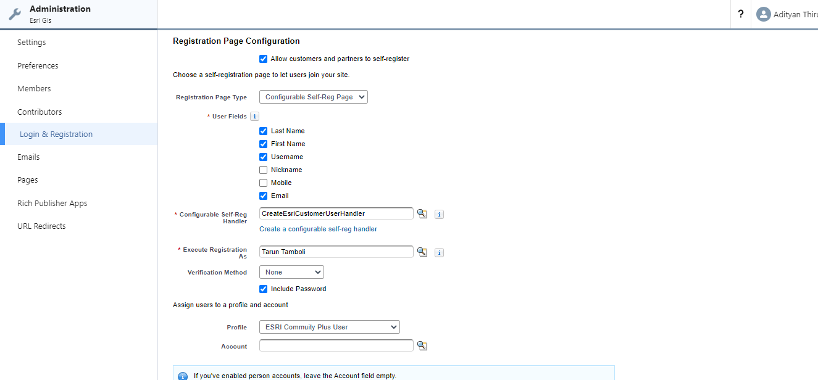
  2. Go to builder -> Click the down arrow icon near the setting icon on top left -> on dropdown list at bottom click on “+New Page” -> Standard Page -> “+new Blank page” -> select “Flexible layout” -> click Next -> give name as “applicant” -> click Create -> New page created with name “applicant” -> click component -> select “Applicant/Wizard” and drag it on the page and then click on Publish at the end.

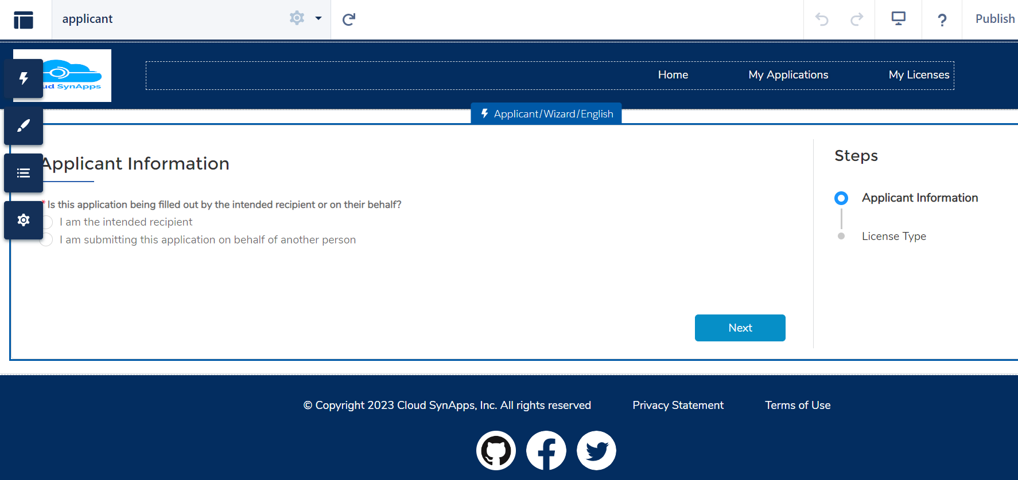

* 1. Delete Record information tab from “Business License Application detail” and ”Business License Detail” page.

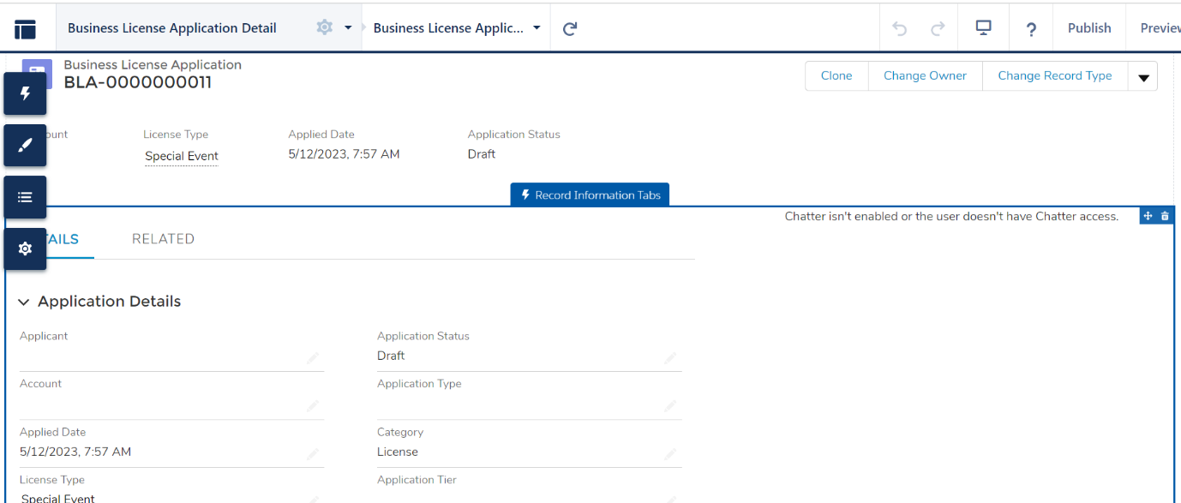

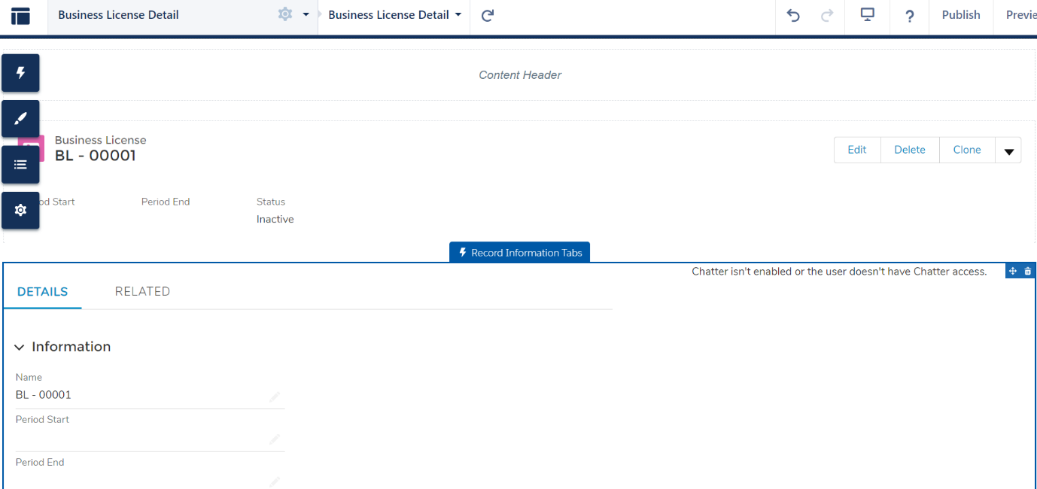

* 1. Add tabs component from components on Business License Application Detail Page and give name as “DETAILS” & “LOCATIONS” to first and second tab.
     + 1. Drag Record Detail page on DETAILS Tab
       2. Drag “applicant” custom component on LOCATIONS Tab.

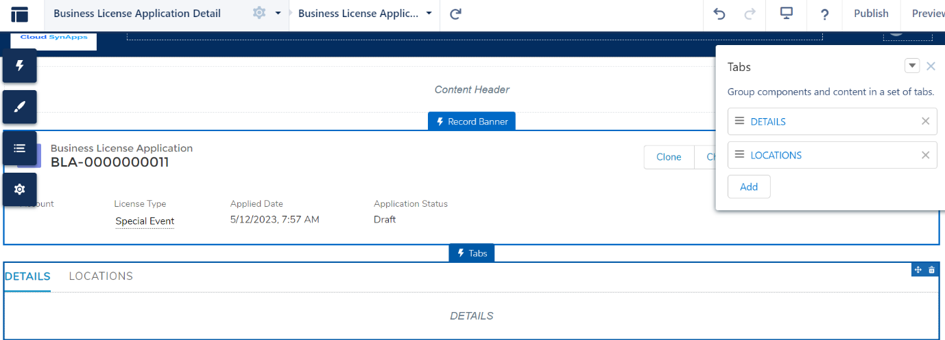

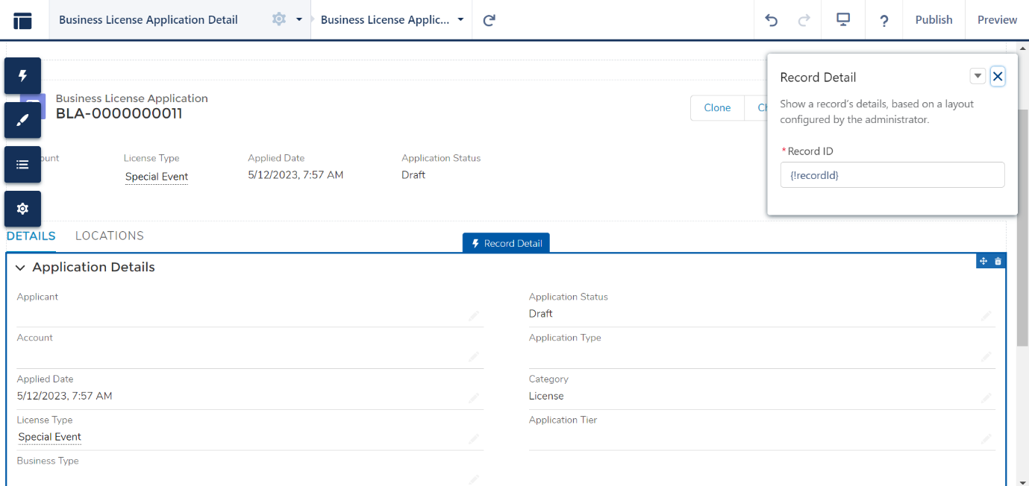

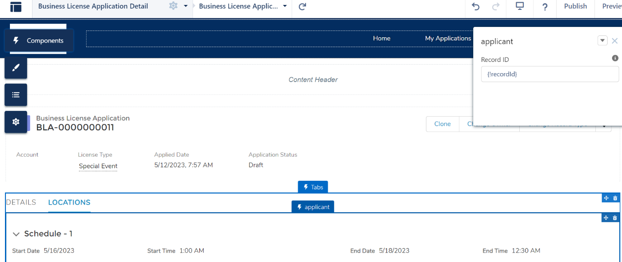

* 1. Add tabs component from components on Business License Detail Page and give name as “DETAILS” & “Approved Locations” to first and second tab.
     + 1. Drag Record Detail page on DETAILS Tab
       2. Drag “applicantLicenseApproved” custom component on Approved Locations Tab.

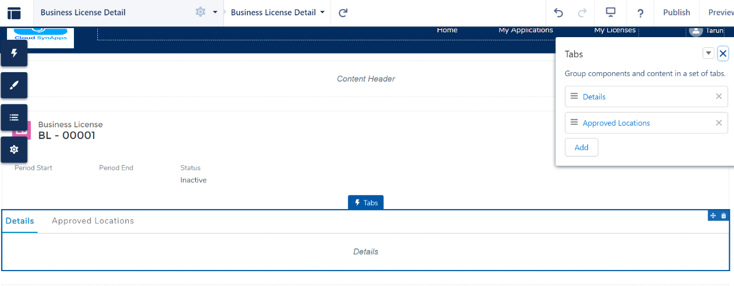

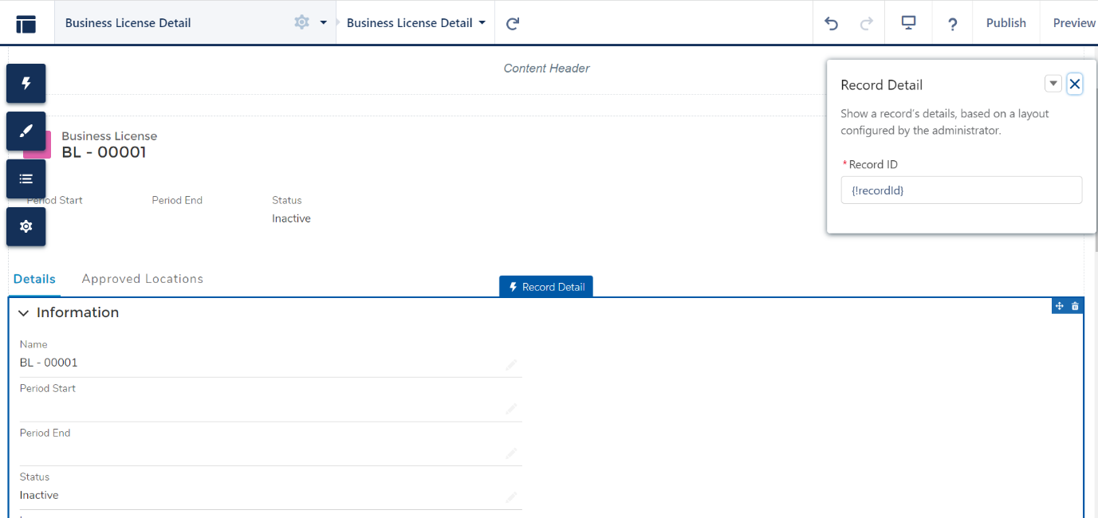

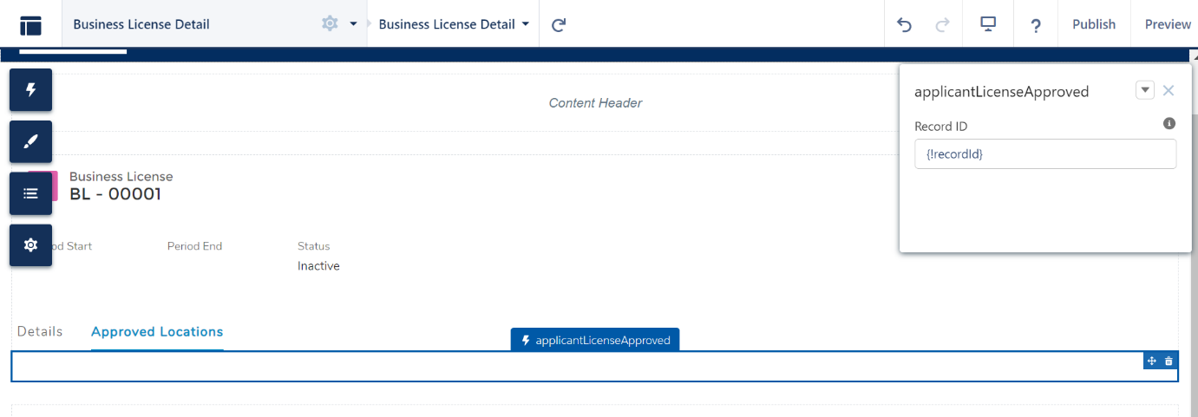

1. Create a new record with the name "Special Event" in the "RegulatoryAuthorizationType" object, so that the BLA that gets created is automatically associated with this authorization type as authorization type is a mandatory field. Also ensure that this authorization type is shared with the Portal Users.

Follow the below steps for creating a new record in RegulatoryAuthorizationType

Click on App Launcher(9 dots) and select “Regulatory Authorization Type” and click on “New”. Enter name as “Special Event” and Authorization Cateogry as “Licenses” and click on “Save”.

Follow these steps for creating a sharing rule.Setup > Sharing settings > Under section “Regulatory Authorization Type Sharing Rules” > New.

* Provide relevant label and Name
* Rule Type : Based on Criteria
* Name : equals : “Special Event”
* Share with : Portal Roles and Subordinates <Choose the Role that gets assigned to the community Users>
* Access Level : <Read Only>

*If there is an existing record for "AuthType" and it is required to associate all BLA's with it, then the omniscript will need to be modified.*

1. **Page Layout Assignment**

Necessary page-layouts have been crated and they can assigned for the respective profiles as per the requirement. For assigning page-layouts, goto object manager > select object > Page Layouts > Click on Page-Layout Assignment.

1. Security Settings
   1. It is currently not supported to move permissions of standard object in profile / permission set via package. Below are the changes to be made at permission set level for standard objects.
   2. Navigation path > Setup > Sharing Settings > edit > Polygon, Polygon Schedule & Authorization Location Access Schedule > public Read for both internal and external.
   3. Navigation path > Setup > Permission sets> Open below permission sets > Object Settings > Click on Edit and provide permissions like below. Click on Save
   4. Permission Set : ESRI Community

|  |  |
| --- | --- |
| Object Name | Permissions |
| Account | Read, Create, Edit |
| Location | Read, Create, Edit |
| Authorization Application Places | Read, Create |
| Authorization Location Access Schedules | Read, Create, Edit |
| Business License Applications | Read, create |
| Business Licenses | Read |
| DataRaptor Bulk Data | Read, Create, Edit |
| Regulatory Authorization Types | Read |
| Polygon | Read, Create |

* 1. Permission Set : Reviewers

|  |  |
| --- | --- |
| Object Name | Permissions |
| Account | Read, Create, Edit |
| Location | Read, ViewAll |
| Authorization Application Places | Read, ViewAll |
| Authorization Location Access Schedules | Read, ViewAll |
| Business License Applications | Read, Edit, ViewAll |
| Business Licenses | Read, Create, ViewAll |
| Contacts | Read, ViewAll |
| Locations | Read, ViewAll |
| Polygon | Read, Edit, View All |
| Regulatory Authorization Types | Read, View All |

### 3.1.3 Basic Provisions

#### APPLICANT WIZARD(OMNISCRIPT)

The "Applicant Wizard" Omniscript is integrated into the community to provide an easy step-by-step process for applicants. Any changes or modifications to the wizard can be made to the Omniscript as per the specific requirements, including adding new steps or modifying existing ones.

* 1. The element "allowMultipleLocations" in omniscript determines whether the "Save and add More" button should be displayed to the applicant while they plot locations on a map. This element can be modified based on the requirement to enable or disable the button.
  2. The omniscript in the application is currently configured to map any new Business License Application with the RegulatoryAuthorizationType record named 'Special Event'. However, this mapping can be modified based on the specific requirements of the application.

#### CUSTOM METADATA

The application has been designed to maintain scalability by deriving most of its terms from custom metadata. The following sections provide a brief description of the significance of each record in the metadata.

##### Feature Layer (Feature_Layers__mdt)

* This custom metadata holds the details of feature layer filters that are displayed to the Reviewer during the process of reviewing the locations of a Business License Application (BLA). Each record in the metadata corresponds to a feature layer and plays a role in determining the filters that will be available to the Reviewer.

##### Reviewer Taks (Reviewer_Tasks__mdt)

* To ensure a structured process, whenever the status of a Business License Application (BLA) is changed to "Awaiting Review", tasks are automatically created. The creation of these tasks is determined by the custom metadata record "Reviewer Tasks".
  + The metadata field "Map_Review_Activity__c" determines if a location review activity is being performed, and maps will be rendered based on this field.

##### Utils (Utils__mdt)

* This metadata is utilized to replace hard-coded values in Apex and other components, allowing for greater flexibility and easier maintenance of the system.
  + Each record of this metadata and their significance will be covered in various sections of this document.

## Applicant

Applicant should be first registered in the community and then logged-in. Below screen will be shown after logging into the community

1 : For creating a new application

2 : For viewing the existing applications of the applicant

3 : For viewing the licenses of the approved applications of the applicant

### 3.2.1 Creating new Application

* Click on Raise Application in the above screen and choose the relevant option as per the below screen

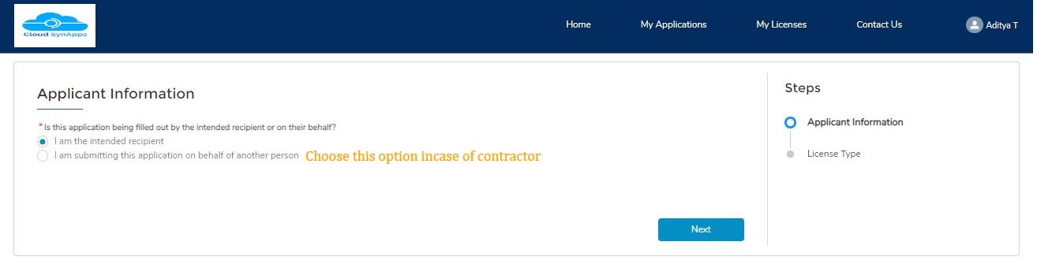

* Choose License Type as “Special Event” and click on “Next”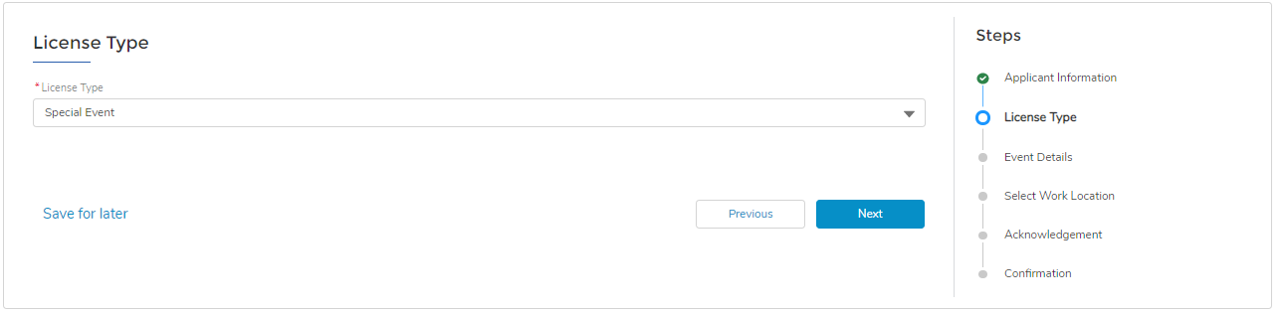
* Provide necessary details and click on “Next”

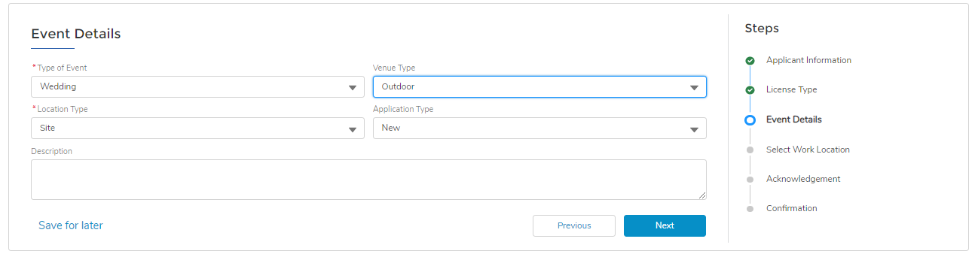

* You’ll be encountered with the below screen.

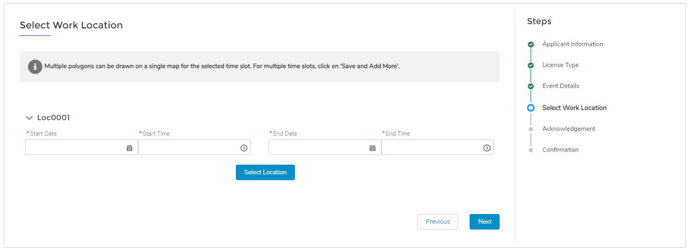

* Provide values for Start date time, End Date Time and click on “Select Location” and below screen will be appearing. Points to consider :
  + Map will be loaded with already Approved polygons for the selected time-slot and the applicant cannot draw any polygon overlapping the already approved polygon.
  + Applicant can type for a specific location in the given search box.
    - Default location is being determined by the records “Default_Latitude” and “Default_Longitude” in the metadata “Utils__mdt”. Default location can be altered by admin via modifying the mentioned records
  + All the colors of the polygon are completely configured by updating the necessary records are the metadata “Utils__mdt”.
  + It is important to click on either “Save” or “Save and More” depending on the request prior to click of “Next”. Plotted details will be captured clicking on either of the save buttons.
  + Applicant has the ability to draw a polygon, but there are no transformation controls provided. If the applicant mistakenly draws a polygon at an incorrect location, it cannot be altered or moved, and must be deleted and redrawn.

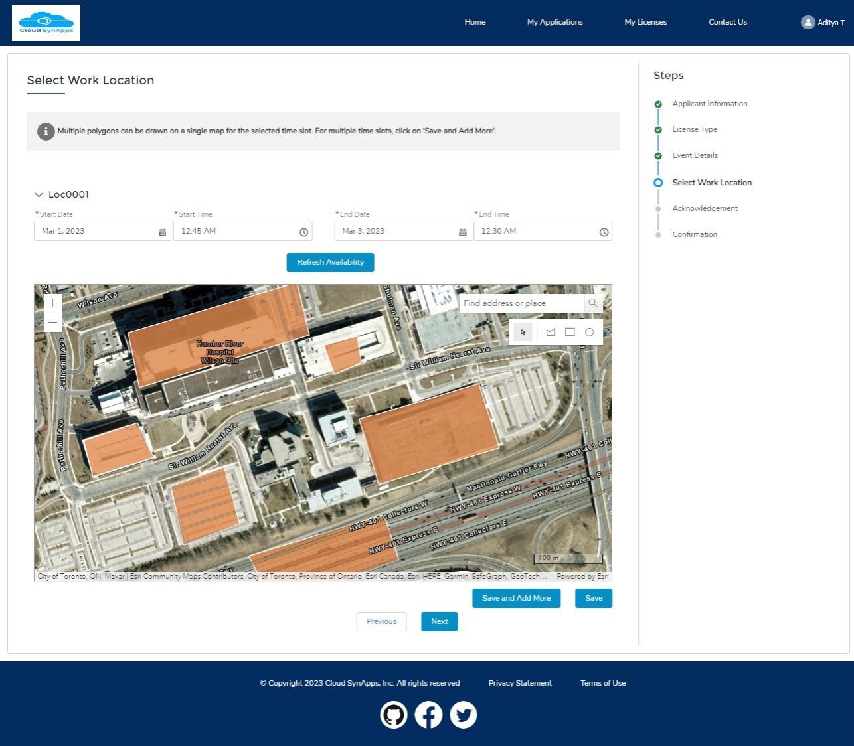

* Once the user clicks on "Save", they will receive a message stating- "Save successful". After receiving the message, the user can proceed to click on "Next".
* Provide acknowledgement and click on “Next”. A new Business License Application will get created.

### 3.2.2 Viewing Existing Applications

After submitting an application, applicants can track the status of their application by navigating to the "My Applications" tab (referenced as #2 in the image at 3.2). The "My Applications" tab will display a list view of all the applications submitted by the applicant, and they can click on a specific application to view its status and a specific tab “Locations” is present to track the status of individual location for this Application

#### Polygon Status Check

Accordion will be loaded based on the count of time-slots selected for the applicant. There is a possibility of few polygons to get approved and few to get rejected and so which the provision of showing the details on hover of a polygon is provided to the Applicant. Applicant can hover on a polygon to see the current status.

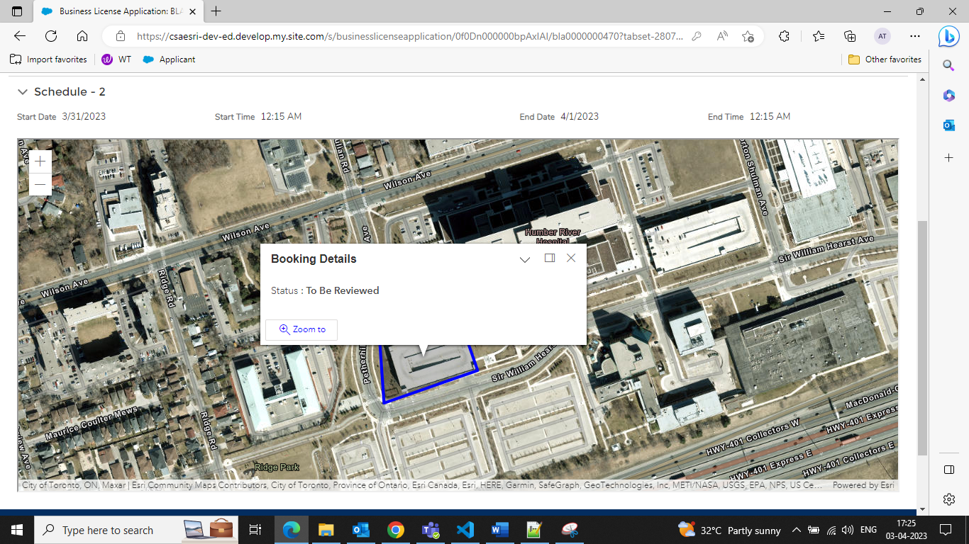

#### Polygon Altered

If the polygon is modified by the Reviewer, the applicant will encounter the below showing the initial version of the polygon created by the applicant and the modified version by the reviewer, superimposed on each other to highlight the changes made.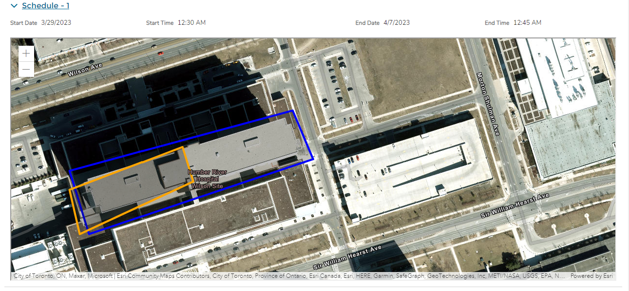

As alterations may have been made by the reviewer, both versions of the polygon will be displayed. The orange version represents the reviewer's version, while the blue version represents the original version submitted by the applicant. To view the details of each version, the applicant can hover over the respective polygons.

#### Polygon Approved / Rejected

If the polygon is rejected / approved by the Reviewer, the applicant will be seeing the below screen and on hover of the polygon comments can be seen(if present).

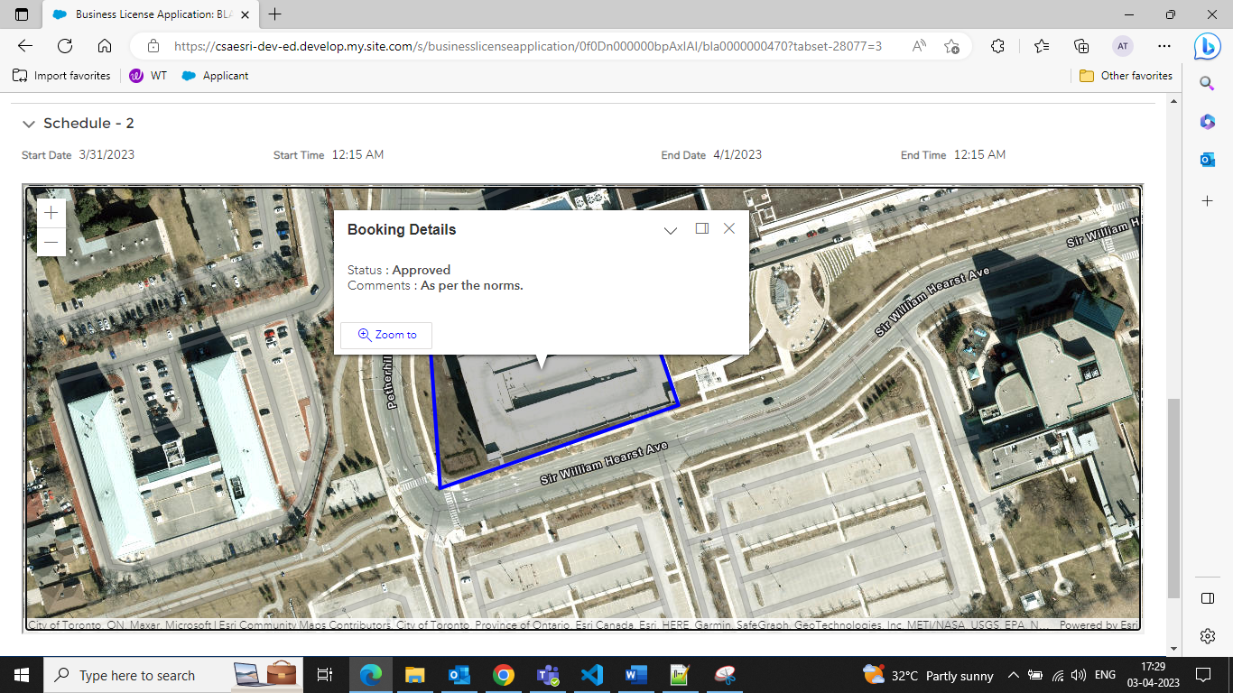

### 3.2.3 Viewing License

To view licenses, applicants can click on the "My Licenses" tab. The license will have the same name as their Business License Application (BLA), but with "BL" instead of "BLA". Upon opening a BL, the applicant can view the approved polygons as part of their application (Refer to image below).

For admins

* Business License gets created and will be stamped on the Business License Application record. Creation of Business License and field populating happens via the flow “BLA - Business License Creator Flow”. For any change to be made on the Business License, flow has to be modified.

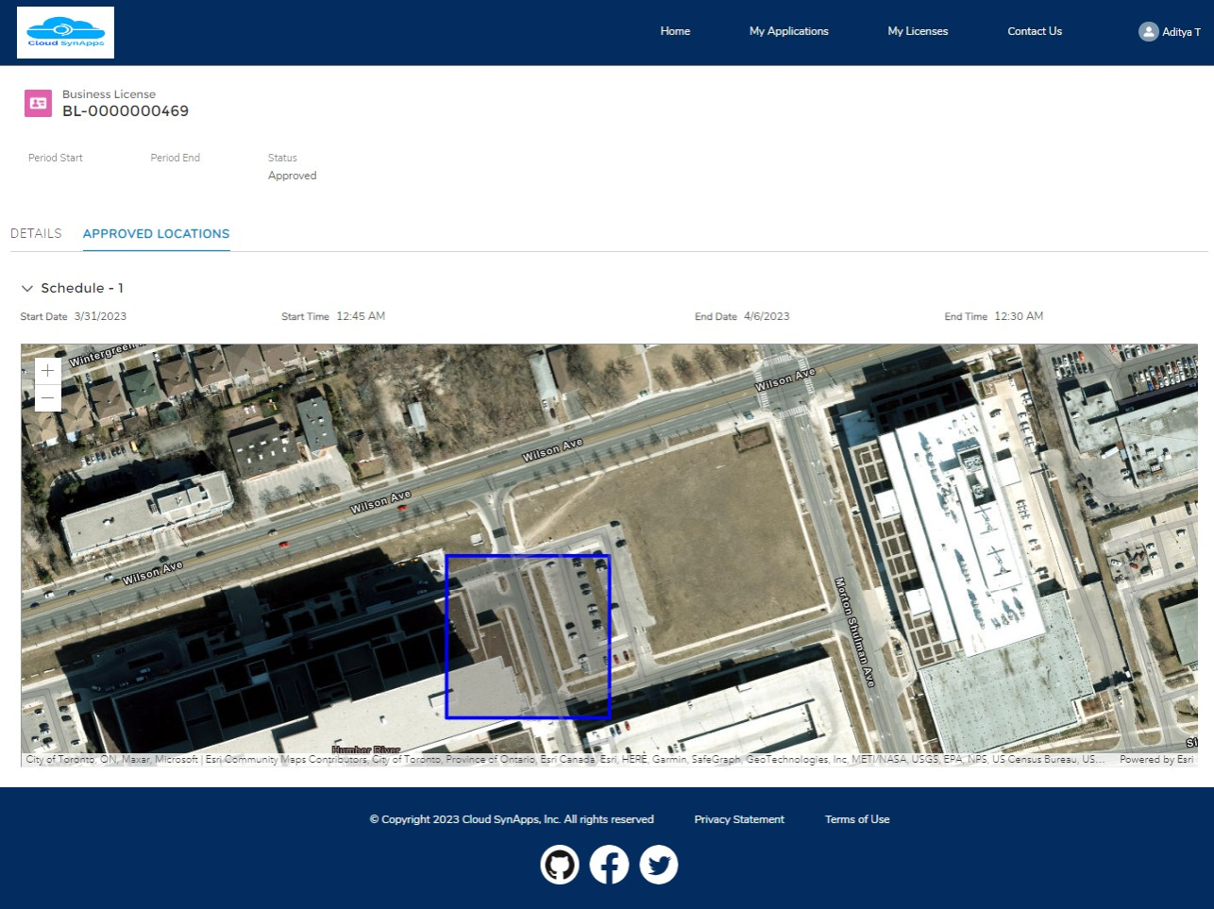

## Reviewer

After a Business License Application (BLA) is created, any reviewer who is part of the Reviewer Queue will receive a notification. Clicking on the notification will redirect the reviewer to the corresponding Business License Application record.

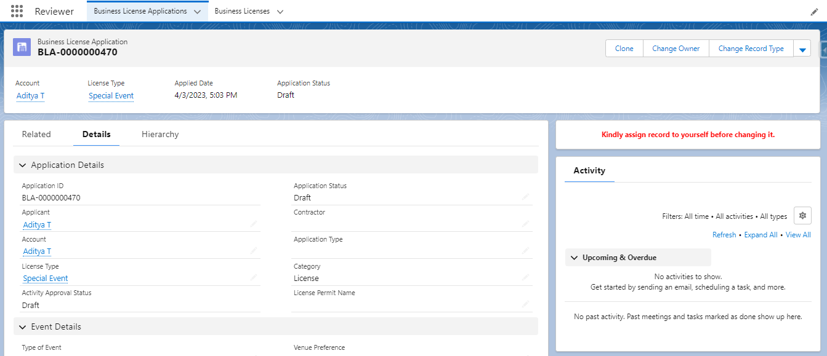

It is advised that that Reviewer should do like below

* Assign the BLA to themselves so that no two reviewers will be working on the same application. This can be done by clicking on the Change Owner button.
* Verify the details and change the Application Status to “Awaiting Review” so that necessary activities will be created.
  + Activities can be configured from the “Reviewer Activities” custom metadata.
* After changing the status to “Awaiting Review” based on the configured records, necessary activity records will get created and will be shown on the right panel like below

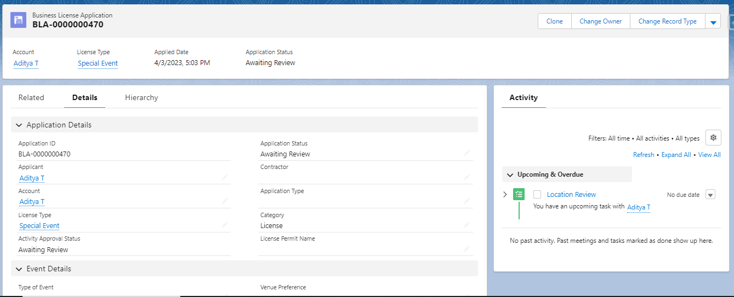  
Now open the Location Review activity for reviewing the location of the Business License Application.

### Reviewing a Polygon

After opening the task, below screen appears. It is recommended that the status is updated to “In Progress” for accurate tracking.

* Update the status to In Progress and click on Review Locations tab

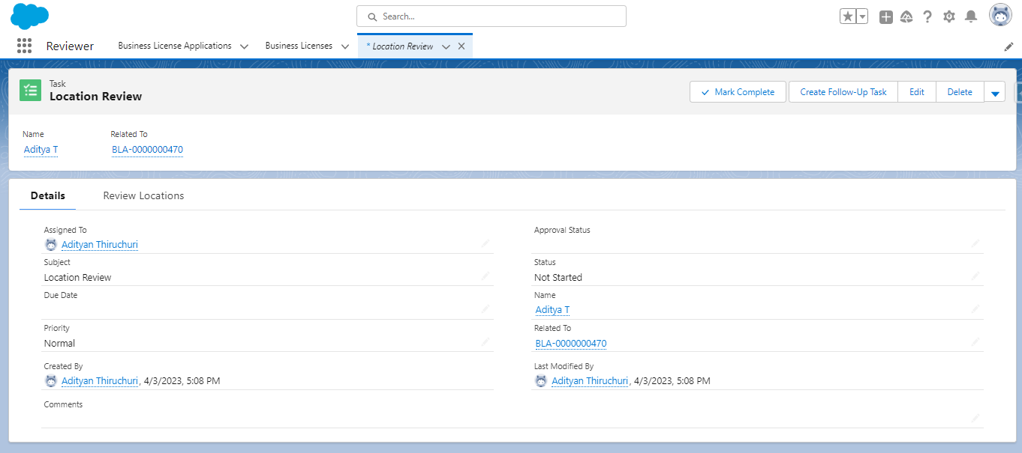

After click of Review Locations, all the areas to be reviewed will be appearing in accordion style. By default only the first area will be expanded and all others will be collapsed.

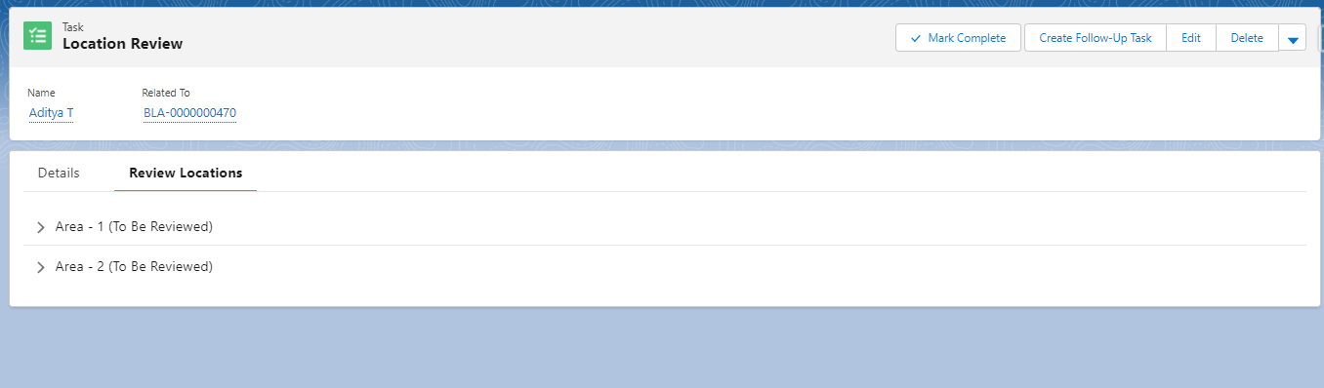

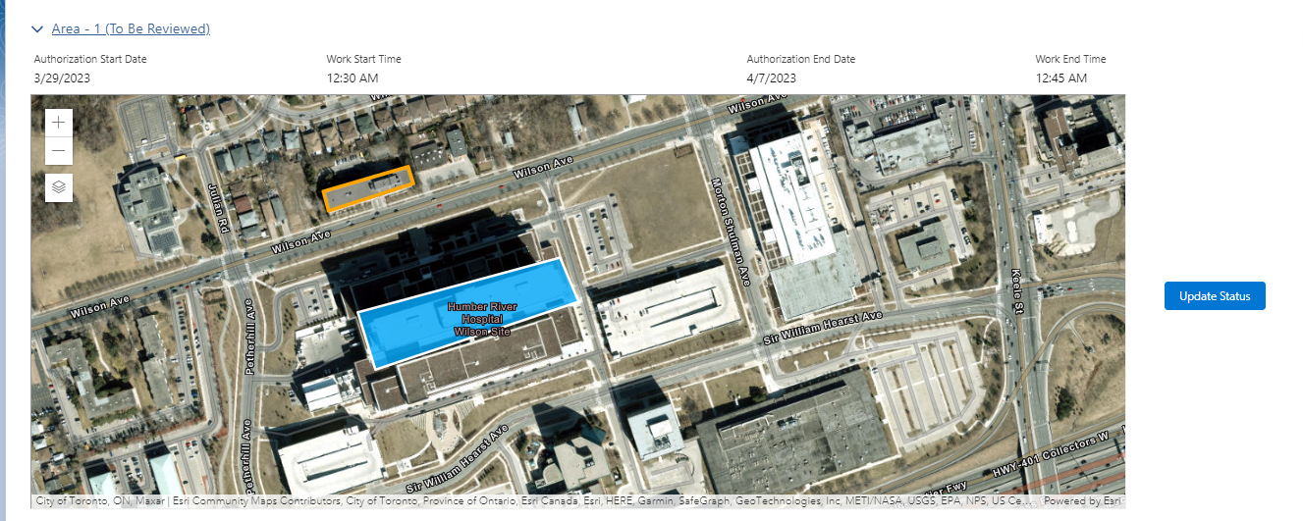

The polygon that requires review will appear in blue colour, which can be configured in the Utils metadata. All other polygons will appear in orange colour. The reviewer will be able to see all polygons except for those with a "rejected" status. They will have the option to approve, reject, or modify the polygons.

### Altering a Polygon

When the reviewer clicks on the blue polygon that requires review, transformation controls will appear. This allows the reviewer to adjust the location of the polygon. Once the necessary alterations have been made, a "Save" button will appear. If the save is successful, a toast message will appear indicating that the review has been successful. Additionally, a hyperlink will be provided to send an email to the applicant informing them of the changes made.

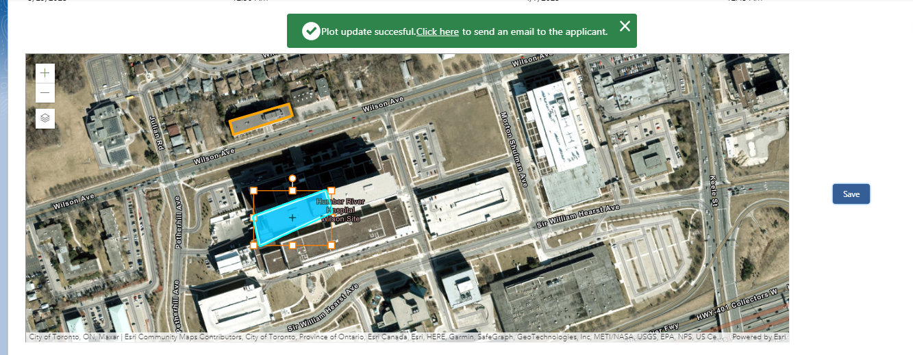

### Approving / Rejecting Polygon

Reviewer can just click on the Update Status button and that will open a modal popup asking about the comments (non-mandatory) and the status to be provided.

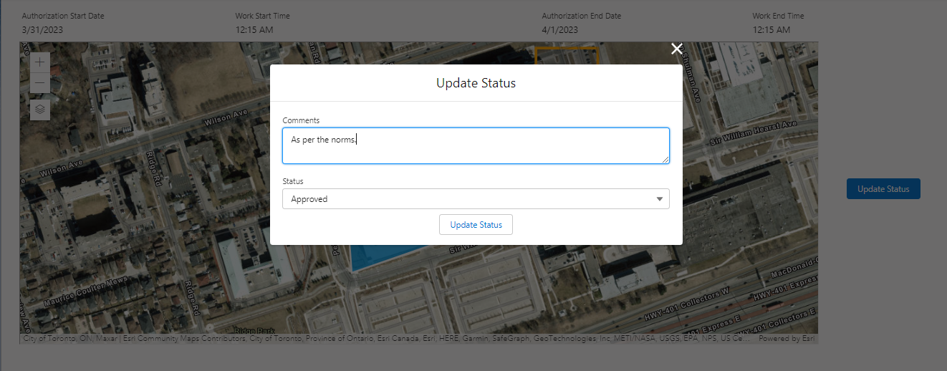

After the reviewer has approved all polygons, they should update the task status. The following points are important to note:

* The task status should be marked as completed, and the approval status should be either "rejected" or "approved."
* Comments must be entered regarding the review process.

Once all tasks have been completed, the status of the Business License Application (BLA) will change to "Review Completed." The reviewer can then conduct a final check and update the status to either "Approved" or "Rejected." This concludes the application's journey. If the status of BLA is changed to “Approved” a new Business License will get created.

# Troubleshooting

1. If the map does not load, refreshing the page may resolve the issue and allow the map to load properly.
2. To resolve any issues with the omniscript not launching correctly, please make sure that LWS is enabled.
   1. LWS can be enabled by navigating to setup > quick find > session settings > Check the checkbox “Use Lightning Web Security for Lightning web components (GA) and Aura components (Beta)”
3. All the functionalities are designed to work only in Lightning Experience. Please ensure that the user is in the Lightning Experience to access them.